Prototype is only used for reading properties.

*Write/delete* operations work directly with the object.

* Manipulating/changing/assigning new values of the property is NOT DONE in the prototype but in the object itself

Example:

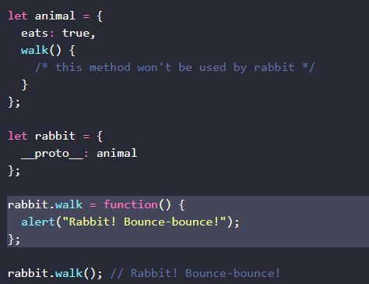

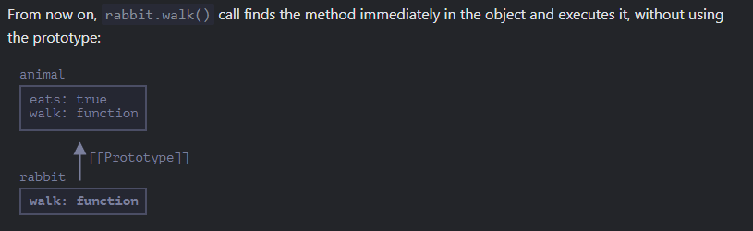

Accessor properties are an EXCEPTION

* Assignment is handled by a setter function
* eg.
  + set
  + get

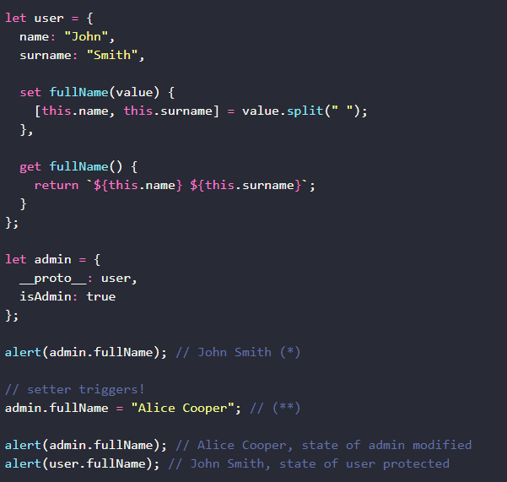

Basically, you can only change a value in a prototype if the prototype has a “set” keyword.